Twilio

Monitor if a page is alive and notify via Twilio SMS if not
# Last amended: 23rd March, 2026
# My folder: D:\Documents\OneDrive\Documents\n8n\2.twilio
# GitHub: This link

1. Ensure that Apache2 is started on the same machine as postfix is installed: Only apache2 is required and not postfix.

./start_apache2.sh

./stop_apache2.sh

2. Workflow:

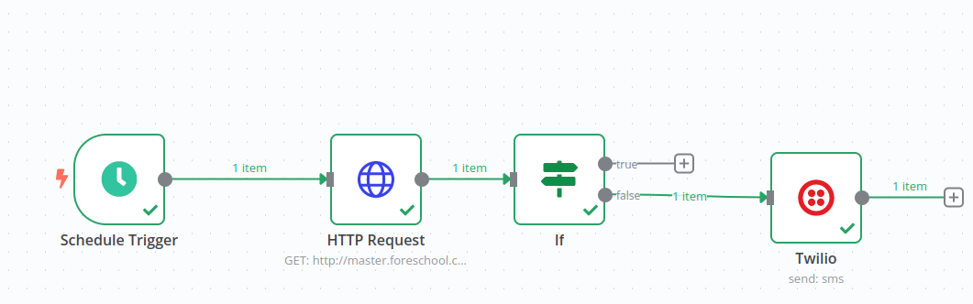Illustration 1: If Bad Request (400) is True, send an SMS.. True branch is connected to Twilio.
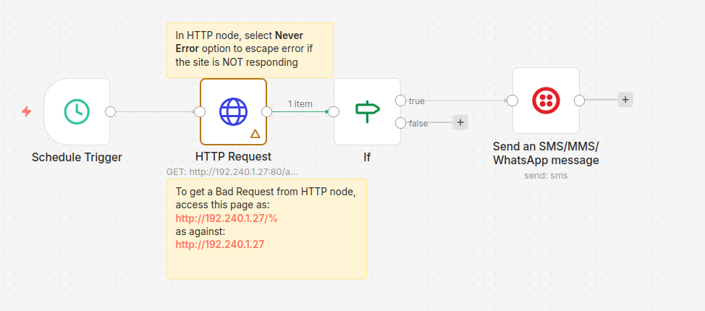
Figure 1: Another workflow

Schedule trigger
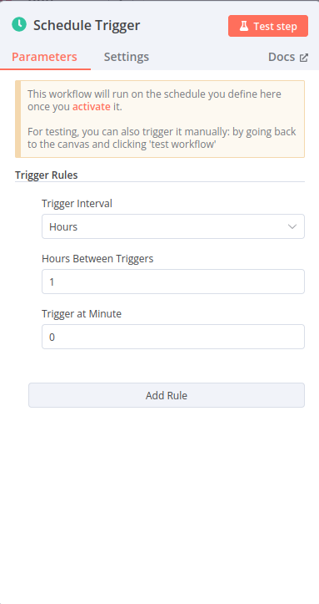
Figure 2: Decide interval of trigger

HTTP Request configuration:

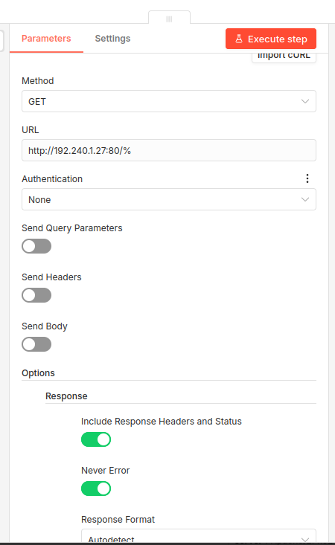
Figure 3:HTTP Request node—Top part of configuration. Note if you have ‘%’ sign at the end of URL, (ie: http://192.240.1.27/%) you will get an Error of status code: 400, else you will get the web page

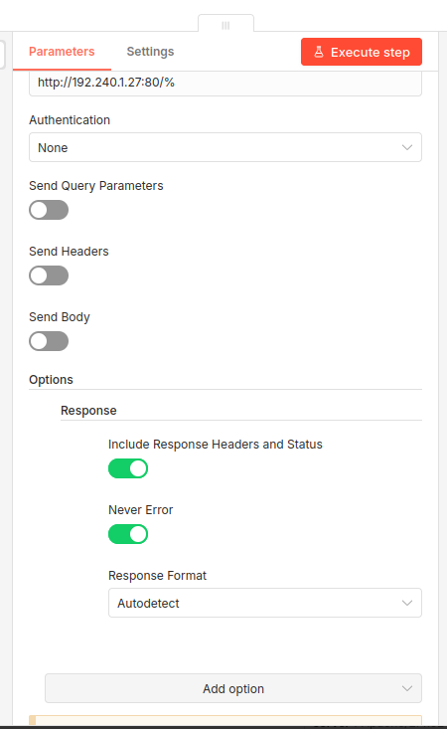
Figure 4: HTTP Request node: Bottom part of configuration. Click Add Option->Response and select the two switches.

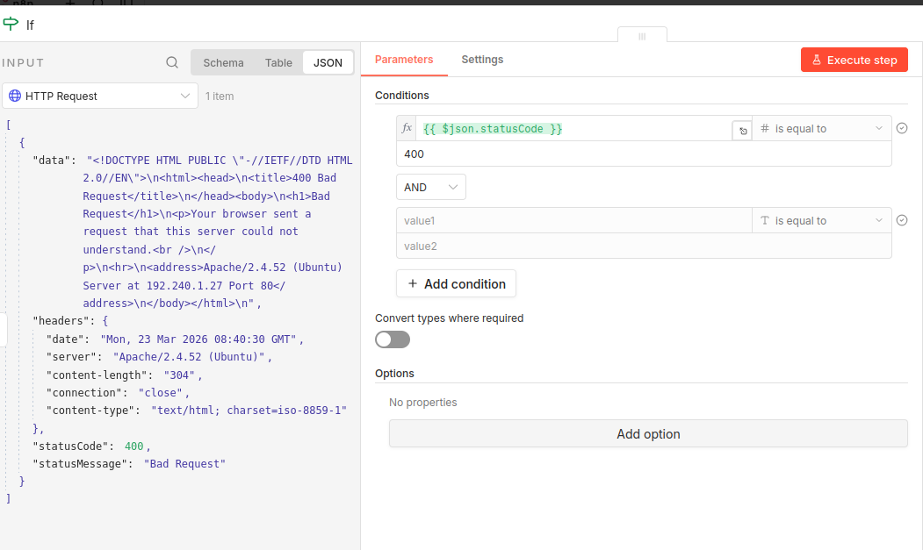
Figure 5: If node. Drag statuscode from left side to here.

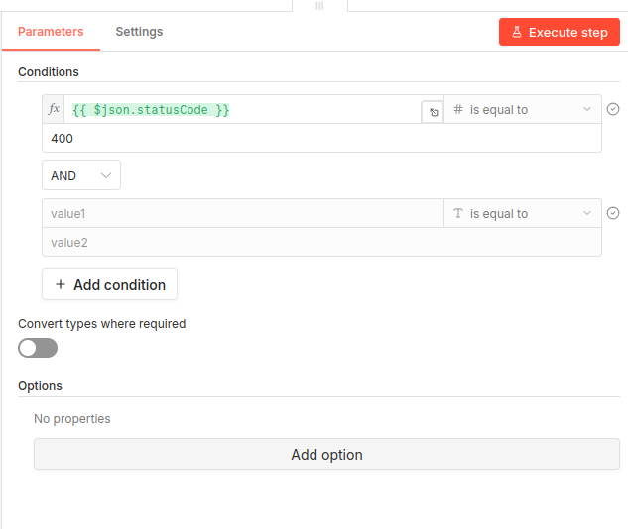
Figure 6: If node with status code dragged.

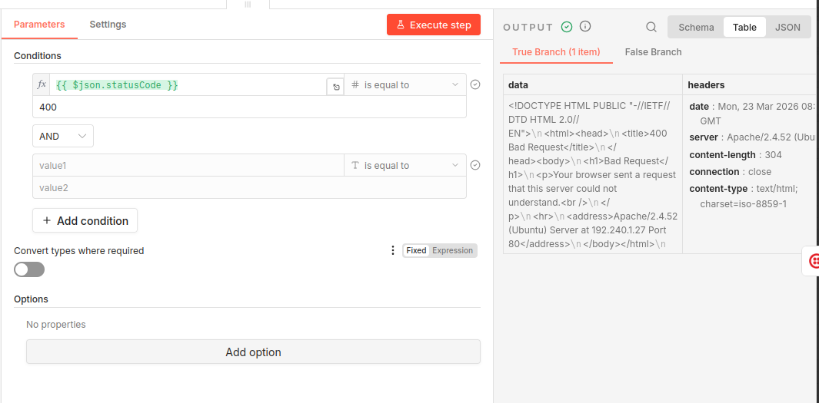
Figure 7: Right side of If node.

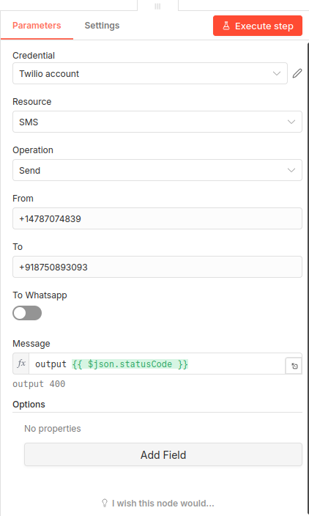
Figure 8: Twilio. Message field also has Status output from previous node dragged here. The message ‘output’ is ANY message or sentence you may wite.

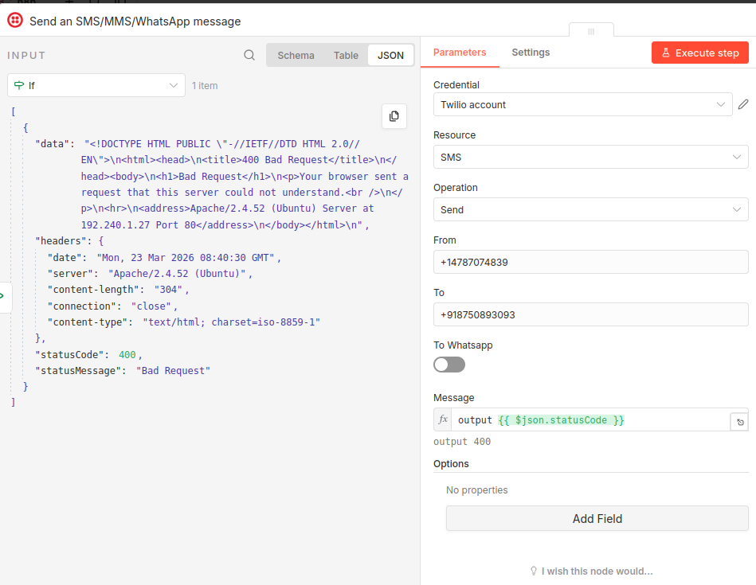
Figure 9: Twilio node. Drag Status Code dragged from left to Message field

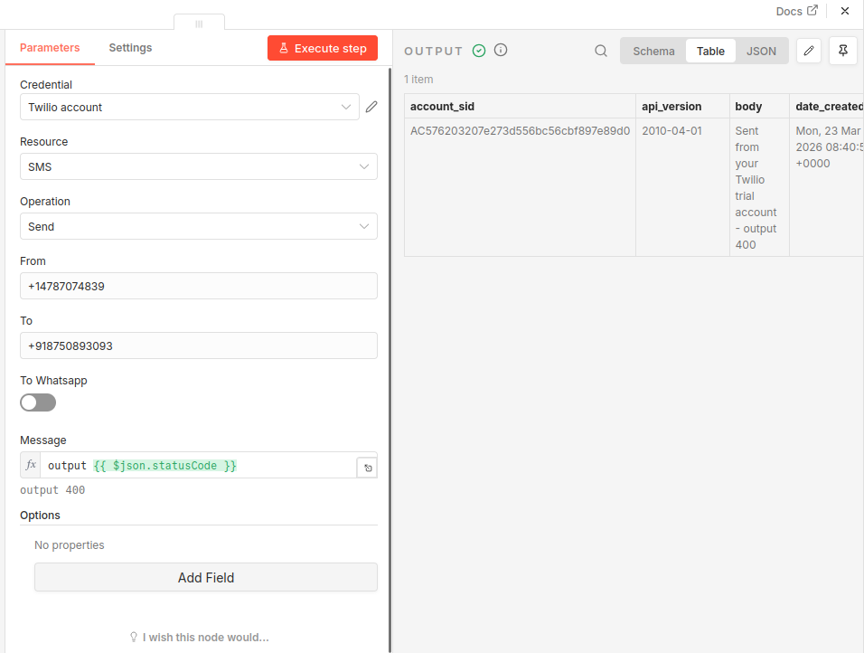
Figure 10: Right side of Twilio node.

Refer here to configure Twilio.

Using Auth Token#
To configure this credential, you'll need a Twilio account and:
- Your Twilio Account SID
- Your Twilio Auth Token
To set up the credential:
- In n8n, select Auth Token as the Auth Type.
- In Twilio, go to Console Dashboard > Account Info.
- Copy your Account SID and enter this in your n8n credential. This acts as a username.
- Cop your Auth Token and enter this in your n8n credential. This acts as a password.
Refer to Auth Tokens and How to Change Them for more information.
###################

